Analyzing Suspicious Activity Report (SAR) Filing Patterns and Money Services Business (MSB) Distribution Across U.S. States
DAT301 — Project 2
David J. Gibbens – www.linkedin.com/in/djogibbens
May 2026

Executive Summary
This project examines Suspicious Activity Report (SAR) filing patterns across the fifty United States and evaluates how these patterns relate to the presence and the role that Money Services Businesses (MSBs) play in the U.S. financial system.

Using Python for data cleaning, exploratory data analysis, and statistical modeling, the analysis integrates three datasets: The U.S. Treasury’s Financial Crimes Enforcement Network (FinCEN) SAR Statistics, the MSB Registrant Database, and a synthetic fraud benchmark dataset sourced from Kaggle.

Results show that SAR filings have increased steadily over time, growing from approximately 1.04 million in 2020 to nearly 1.25 million in 2025, which represents an annualized growth rate of 3.7% and vary substantially across states, industries, and product categories.

A simple linear regression model demonstrates a statistically significant positive relationship between MSB density and SAR filings (β₁ = 46.42, p < 0.001, R² = 0.444), suggesting that states with more MSBs tend to report higher levels of suspicious activity.

While the model explains a meaningful portion of the variation, limitations such as omitted variables and cross-sectional design (the use of aggregated state-level SAR data) constrain causal interpretation. The project provides a foundational analytical framework for understanding financial crime patterns and highlights opportunities for deeper future work.

1. Introduction
Money laundering is the process of concealing the origins of illicitly obtained funds so that they appear legitimate. The process typically unfolds in three stages: placement, in which criminal proceeds are first introduced into the financial system; layering, in which the funds are moved through a series of complex transactions designed to obscure their origin; and integration, in which the laundered money is reintroduced into the legitimate economy. A wide range of predicate crimes generate the proceeds that must be laundered, including drug trafficking, human trafficking, bribery, sanctions evasion, and fraud. Because these criminal enterprises depend on the ability to move and disguise money, the detection and disruption of money laundering is a central objective of financial regulation and law enforcement.

To combat these threats, the Financial Crimes Enforcement Network (FinCEN), a bureau of the U.S. Department of the Treasury, collects and analyzes financial transaction data reported by institutions across the United States. One of FinCEN's key responsibilities is maintaining the national database of Suspicious Activity Reports (SARs) (The Bank Secrecy Act). SARs serve as early-warning indicators of potential financial crime. They are filed when regulated institutions detect unusual or suspicious activity involving fraud, money laundering, terrorist financing, identity theft, structuring, or other illicit behavior. Filing is required for transactions involving $5,000 or more when there is reason to suspect that the funds derive from illegal activity, are designed to evade reporting requirements, or lack a lawful purpose (FinCEN Suspicious Activity Reporting (SAR) Filing Instructions). SARs are mandated under the Bank Secrecy Act (BSA) and constitute a critical tool in combating money laundering, terrorist financing, fraud, and other financial crimes (The Bank Secrecy Act).

SAR filing obligations extend well beyond traditional financial institutions such as banks and credit unions. Casinos, money transmitters, check cashers, currency exchangers, prepaid card providers, broker-dealers, mutual funds, insurance companies, and certain real estate professionals are all subject to SAR reporting requirements. SAR filings are strictly confidential, institutions are prohibited from notifying the subjects of a report, and filers are protected under safe harbor provisions from civil liability for good-faith disclosures (FinCEN Suspicious Activity Reporting (SAR) Filing Instructions).These reports support investigations by a wide range of federal, state, and local agencies, including IRS-Criminal Investigation (IRS-CI), the Drug Enforcement Administration (DEA), the Federal Bureau of Investigation (FBI), Homeland Security Investigations (HSI), the U.S. Secret Service, state attorneys general, local law enforcement, and regulatory bodies such as the Office of the Comptroller of the Currency (OCC), the Federal Reserve, the Federal Deposit Insurance Corporation (FDIC), and FinCEN itself (BSA e-filing system).

Money Services Businesses (MSBs) are non-bank financial institutions that provide services such as money transmission, check cashing, and currency exchange. Defined and regulated by FinCEN under the Bank Secrecy Act, MSBs range from small single-location operators to large multi-state enterprises. The six MSB categories are: (1) money transmitters, who transfer funds with no dollar threshold; (2) check cashers, subject to a $1,000 daily threshold; (3) currency dealers and exchangers; (4) issuers of money orders and traveler's checks; (5) sellers and redeemers of those instruments, including retail agents such as grocery stores; and (6) providers or sellers of prepaid access devices such as prepaid cards and digital wallets (Am I an MSB?). MSBs play a significant role in the financial ecosystem and are often associated with elevated anti-money laundering (AML) risk due to their high transaction volumes, cash-intensive operations, and, in many cases, limited compliance infrastructure.

Understanding how MSB presence relates to SAR activity provides insight into financial crime patterns and regulatory exposure across the United States. This project analyzes SAR filing trends across U.S. states and evaluates the relationship between MSB density and SAR volume using Python-based data wrangling, visualization, and statistical modeling. By integrating multiple datasets and applying regression analysis, the project aims to establish a foundational analytical framework for understanding the geographic dimensions of financial crime reporting.

2. Data Sources

2.1 FinCEN SAR Statistics
The FinCEN SAR Statistics constitute the primary dataset for this analysis, which contains aggregated SAR filing data broken down by year-month, state, industry, regulator, product type, instrument type, and filing count. The dataset comprises 169,140 rows and 7 columns, capturing the volume and composition of suspicious activity reports across multiple dimensions (Sar stats). This dataset provides the dependent variable, total SAR filings by state, for the regression model. Its granularity allows for temporal trend analysis, cross-state comparisons, and breakdowns by industry and product category, making it the cornerstone of the exploratory and inferential analyses presented in this project.

2.2 MSB Registrant Database
The MSB Registrant Database contains detailed registration information for Money Services Businesses operating in the United States. Each record includes business names and addresses, MSB activity types, states of operation, number of branches, and registration dates (MSB registrant search). The dataset consists of 36,704 rows and 13 columns. For the purposes of this project, the MSB Registrant Database is used to compute MSB density by state that is, the total count of registered MSBs in each state which serves as the independent variable in the regression model. The diversity of MSB types and geographic distribution in this dataset enables a meaningful examination of how the presence of non-bank financial service providers relates to SAR filing volumes.

2.3 Fraud Dataset Benchmark (FDB)
The third dataset is a synthetic transaction-level fraud benchmark dataset containing 50,000 rows and 21 columns and was sourced from Kaggle (Arbab). Each record includes transaction amounts and types, device and location data, behavioral features, and a binary fraud label. While this dataset was not incorporated into the regression model, it supports exploratory analysis of fraud-related patterns and provides additional context for understanding the types of suspicious activity indicators that might trigger SAR filings. Its inclusion broadens the analytical scope of the project and illustrates the range of data available for financial crime research.

3. Data Cleaning and Preparation

3.1 SAR Dataset
The SAR dataset required several preprocessing steps to prepare it for analysis. Column names were standardized to ensure consistency and ease of reference throughout the codebase. Year-month fields, originally stored as strings, were converted to datetime format to enable temporal aggregation and time-series visualization. Non-data rows such as headers, footers, and summary rows embedded in the raw file were identified and removed. Filing counts were converted from string to numeric type to support arithmetic operations and statistical modeling. Finally, the year was extracted from each datetime value to facilitate annual aggregation of SAR filings.

3.2 MSB Dataset
The MSB Registrant Database underwent its own set of cleaning procedures. Column names were standardized for consistency with the other datasets. State identifiers, which appeared in a variety of formats across the raw data, were cleaned and mapped to standard two-letter U.S. state abbreviations. Records containing invalid or missing state entries were removed to ensure that the state-level aggregation used in the regression model would be accurate and complete.

3.3 Fraud Dataset
The Fraud Dataset Benchmark was prepared for exploratory analysis by converting timestamp fields to datetime format, ensuring that all numeric fields were properly typed, and removing rows with missing values. These steps were necessary to support reliable summary statistics and visualizations. Because this dataset was used solely for exploratory analysis and was not merged with the SAR or MSB data, its cleaning requirements were comparatively straightforward.

3.4 Aggregation and Merging
To construct the modeling dataset, SAR filings were aggregated by state, producing a single total filing count for each state or territory. Similarly, MSB counts were aggregated by state from the registrant database. The two aggregated datasets were then merged into a single combined modeling dataset containing 60 state and territory observations. These steps ensured consistent, reliable data for both exploratory analysis and regression modeling. Importantly, the Fraud Dataset Benchmark was used only for exploratory data analysis and was not merged into the modeling dataset, preserving the integrity of the regression framework.

4. Exploratory Data Analysis

4.1 Annual SAR Trends
SAR filings increased steadily from 2020 through 2025, reflecting a sustained upward trajectory in suspicious activity reporting across the United States. Total filings grew from approximately 1,037,415 in 2020 to 1,134,644 in 2021, 1,138,835 in 2022, 1,200,926 in 2023, 1,193,168 in 2024, and 1,249,088 in 2025. The 2026 total stands at 656,538, but this figure represents a partial year and should not be interpreted as a decline in filing activity. This sustained growth most likely reflects multiple converging trends: heightened fraud activity in the wake of the COVID-19 pandemic, increased digital transaction volumes, broader adoption of automated transaction monitoring systems by financial institutions, and evolving regulatory expectations that have lowered the threshold for filing. When interpreting SAR volume trends, it is essential to distinguish between genuine shifts in filing behavior and the partial data set for 2026, which only includes three months of SAR filing data for 2026.

Year | Total SAR Filings
2020 | 1,037,415
2021 | 1,134,644
2022 | 1,138,835
2023 | 1,200,926
2024 | 1,193,168
2025 | 1,249,088
2026 (partial) | 656,538

4.2 SAR Filings by State
The geographic distribution of SAR filings reveals substantial variation across the U.S. California, New York, Florida, and Texas are the states with the highest SAR volumes as noted in the chart below (Sar stats). These states share several characteristics: large populations, diverse financial sectors, and significant economic activity. They host dense concentrations of banks, MSBs, fintech platforms, and international financial gateways, all of which generate high volumes of reportable transactions. The geographic concentration of SAR filings closely mirrors population and economic activity patterns.
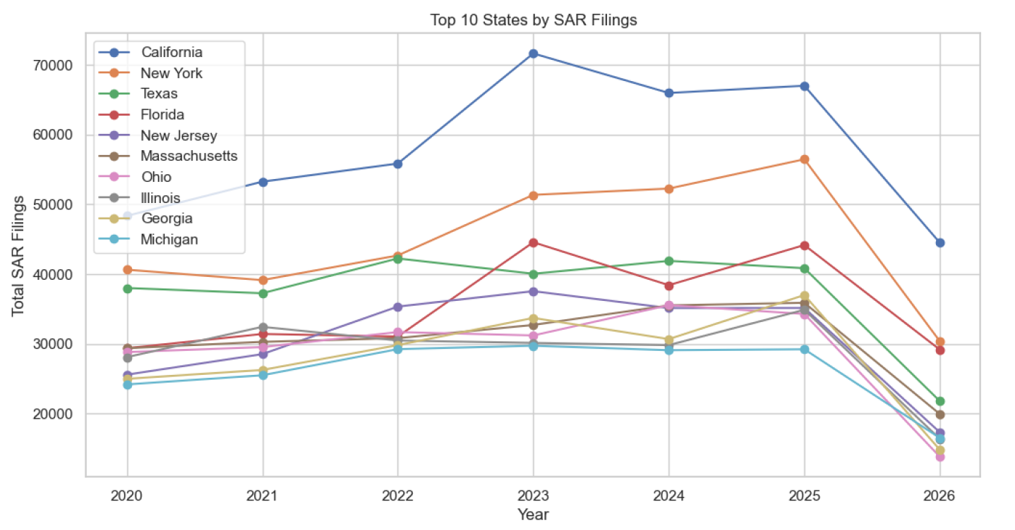

4.3 SAR Filings by Industry and Product

An examination of SAR filings by industry reveals that depository institutions including commercial banks, savings associations, and credit unions account for a substantial share of total filings. MSBs also contribute a significant proportion, consistent with their high transaction volumes and elevated AML risk profiles. These products are frequently associated with suspicious activity because they are widely used in both legitimate commerce and illicit financial schemes, including structuring, layering, and fraudulent fund transfers. The concentration of filings across a relatively small number of industries and product types underscores the importance of targeted compliance and monitoring strategies.

As illustrated in the chart below, which displays total SAR filings by financial product type (excluding roll-up aggregate categories to prevent double counting), deposit accounts and debit cards dominate the filing landscape, each exceeding two million total reports. Credit cards and the residual “Other” category follow at approximately one million filings each, while prepaid access, home equity lines of credit, stocks, residential mortgages, foreign exchange transactions, and mutual funds account for progressively smaller shares.

Each product category reflects a distinct segment of the financial system. Deposit accounts, standard checking and savings accounts held at banks and credit unions, are the most reported product type due to their near-universal use in both everyday transactions and illicit fund placement and layering activities. Debit cards, which draw directly from deposit account balances, are closely associated with rapid cash conversion schemes, point-of-sale structuring, and fraudulent transactions. Credit cards are frequently flagged in connection with bust-out fraud, refund abuse, and identity theft. Prepaid access instruments, including reloadable prepaid cards and stored-value products, are of particular concern to FinCEN because they can function similarly to cash portable, often anonymous, and difficult to trace across jurisdictions making them a common tool in structuring and money mule operations. Home equity lines of credit (HELOCs) appear in SAR filings related to mortgage fraud and real estate-based money laundering schemes. Stocks and mutual funds are associated with securities fraud, layering through investment accounts, and wash trading. Residential mortgage products are flagged in connection with property-based laundering, including inflated appraisals and straw buyer arrangements. Foreign exchange (forex) transactions are reported when suspicious patterns suggest currency conversion is being used to obscure fund origins or facilitate cross-border value transfer. The Other category, as defined by FinCEN, captures financial instruments that do not fall within the named product classifications, including money orders, cashier's checks, and certain ACH transactions.

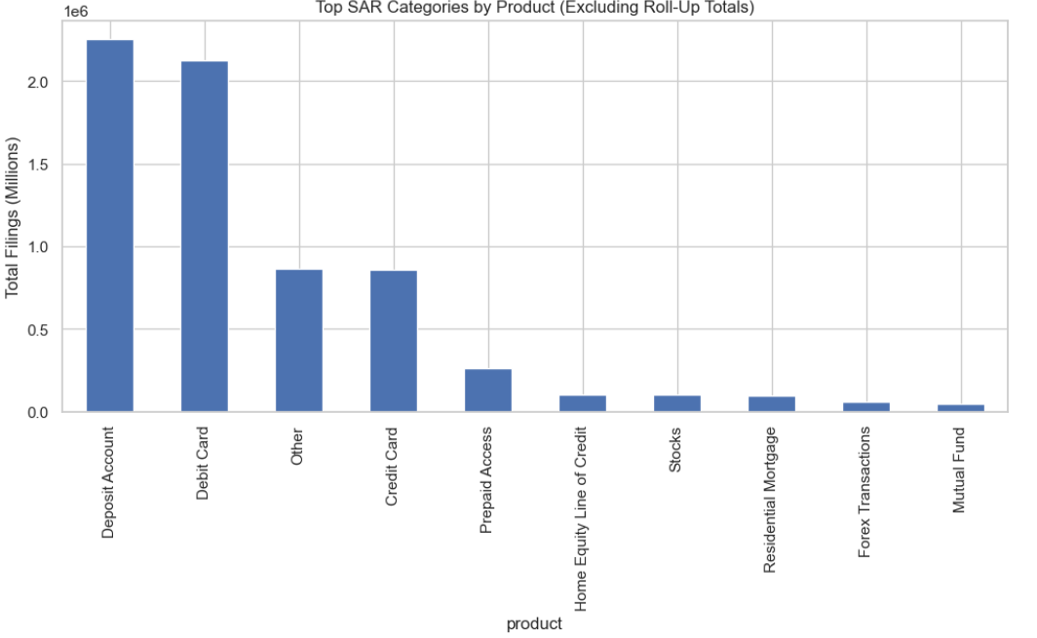

4.4 MSB Distribution Across States
The distribution of registered MSBs across U.S. states is highly uneven, with a small number of states hosting a disproportionately large share of all MSBs. California leads the nation with 5,912 registered MSBs, far exceeding any other state. Colorado, Texas, Michigan, and New York also rank among the top states for MSB presence. The states with the highest MSB counts tend to have large populations, diverse economies, and significant immigrant and remittance-sending communities all of which increase demand for money transmission, check cashing, and currency exchange services. As noted in the chart below, this uneven distribution of MSB across the U.S. creates a natural experiment: it allows researchers to test whether states with higher MSB density also experience higher SAR filing volumes, controlling for the baseline level of financial activity.
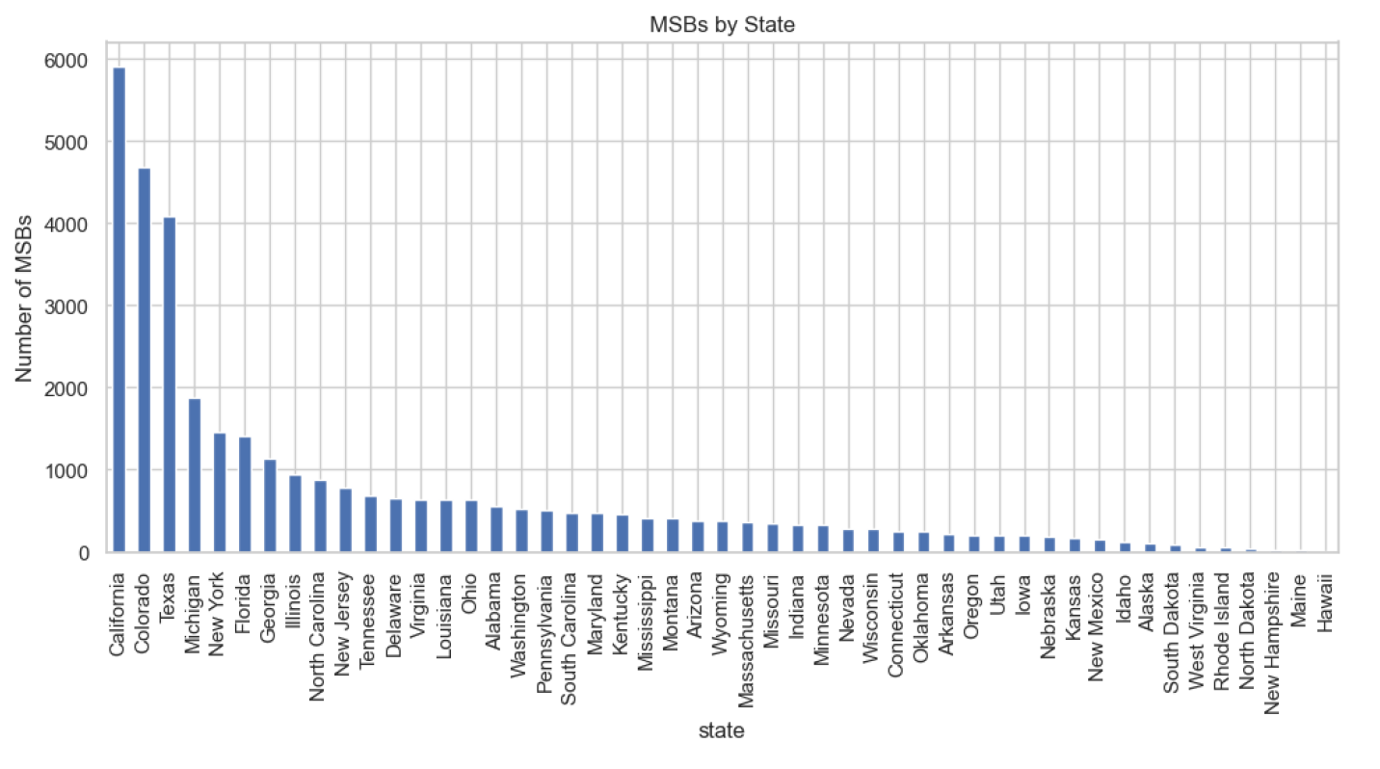

4.5 SAR vs. MSB Scatterplot
A scatterplot of SAR filings versus MSB counts by state reveals a clear positive linear relationship between the two variables. As the number of registered MSBs in a state increases, the total volume of SAR filings tends to increase as well. California stands out as a notable outlier in the upper-right quadrant of the plot, reflecting both its massive MSB presence and its dominant SAR filing volume. Although MSBs do not file the largest percentage of SARs directly, they generate substantial transaction volume that flows through banks and other regulated institutions, which indirectly amplifies their impact on SAR reporting . The positive trend observed in the scatterplot is strong and consistent enough to justify formal statistical modeling, motivating the regression analysis presented in the following section.
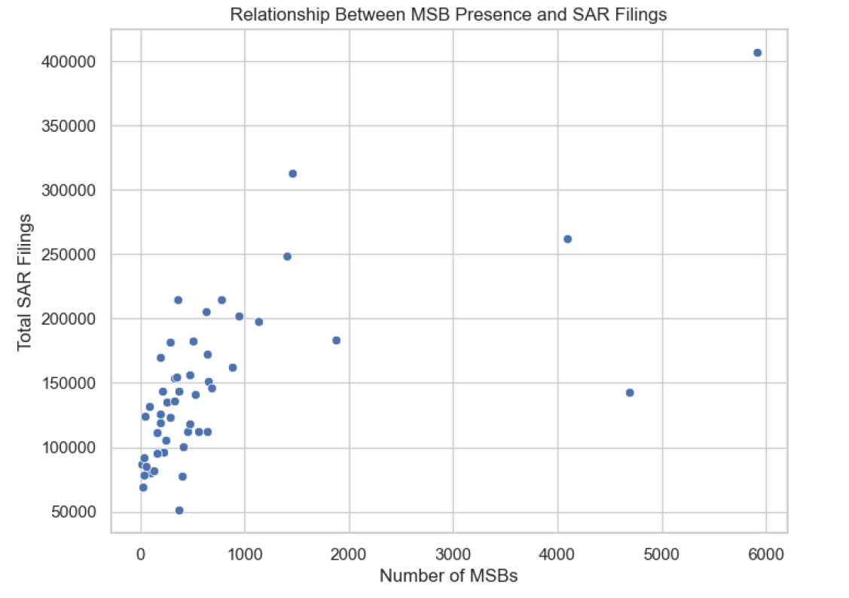

5. Regression Model

5.1 Model Specification
To formally assess the relationship between MSB presence and SAR filing volume, a simple linear regression model was created using ordinary least squares (OLS). The model can be written in the following equation.:
SAR Count = β₀ + β₁ × MSB Count + ε
The dependent variable in this equation, is the total number of SAR filings in each state, the independent variable is the total count of registered MSBs in each state, β₀ is the intercept, β₁ is the slope coefficient, and ε represents the error term. The model was estimated using 60 state and territory observations drawn from the merged modeling dataset.

5.2 Key Results
The regression results are summarized in the table below.

Parameter | Value
Coefficient (β₁) | 46.4179
Standard Error (β₁) | 6.909
t-statistic (β₁) | 6.914
p-value (β₁) | < 0.001 (3.51 × 10⁻⁹)
95% Confidence Interval (β₁) | [33.946, 61.586]
Intercept (β₀) | 99,050
Standard Error (β₀) | 8,329.327
t-statistic (β₀) | 11.478
R² | 0.444
Adjusted R² | 0.435
F-statistic | 47.80
Durbin-Watson | 2.106
Observations (n) | 60

5.3 Interpretation
The estimated slope coefficient of 46.42 indicates that each additional registered MSB in a state is associated with approximately 46 additional SAR filings, holding all else constant. This relationship is highly statistically significant, with a p-value of approximately 3.51 × 10⁻⁹ which is far below the conventional threshold of 0.001. The 95% confidence interval for the slope ranges from 33.946 to 61.586, indicating that the true population parameter is very likely positive and substantively meaningful. The R² value of 0.444 indicates that the model explains approximately 44% of the cross-state variation in SAR filings a meaningful proportion for a model with only a single predictor. The Durbin-Watson statistic of 2.106 is close to the ideal value of 2.0, suggesting no significant autocorrelation in the residuals and supporting the validity of the standard error estimates.
Critically, the model identifies a statistical association, not a causal relationship. The results align with what we suspected: more MSBs in a state leads to greater financial transaction activity, which in turn creates more opportunities for the detection and reporting of suspicious behavior. However, more than half of the variation in SAR filings remains unexplained by MSB count alone. Factors not included in the model such as state population, gross domestic product, banking density, law enforcement resources, and the stringency of the regulatory environment and MSB “correspondent banking” with commercial banking institutions almost certainly contribute to SAR filing volumes. The model should therefore be interpreted as establishing a strong and significant baseline association rather than a complete explanatory framework.

6. Limitations

6.1 Single-Predictor Model and Omitted Variable Bias
The most significant limitation of this analysis is the use of a single-predictor regression model. While MSB count proves to be a statistically significant predictor of SAR filings, SAR activity is influenced by a complex array of factors that are not captured in the model. State population size, economic conditions, the overall size and composition of the financial sector, law enforcement resources and priorities, and the regulatory environment all contribute to variation in SAR filing volumes. The omission of these variables introduces the potential for omitted variable bias, meaning that the estimated coefficient on MSB count may partially reflect the influence of correlated but unmeasured factors. As a result, the magnitude and significance of the MSB coefficient should be interpreted with appropriate caution.

6.2 Cross-Sectional Design

Although the underlying SAR dataset spans seven years of filing activity from 2020 through 2026, the regression model aggregates all filings into a single cumulative total per state before modeling. This design does not account for changes over time in either MSB presence or SAR filing behavior and as such, the model cannot distinguish between states that have experienced recent growth in MSBs and those with stable long-term MSB presence. More importantly, cross-sectional designs inherently limit the ability to draw causal inferences, as they cannot control for unobserved time-invariant factors or establish temporal precedence between the independent and dependent variables.

6.3 Reporting Variability

SAR filing behavior is not uniform across states, even though SAR reporting obligations are governed exclusively at the federal level under the Bank Secrecy Act and enforced by federal regulators including FinCEN, the OCC, the FDIC, and the Federal Reserve. Because the federal framework applies uniformly, state governments do not set SAR filing thresholds or independently regulate reporting standards. However, meaningful variation in filing volume can still arise from sources that are difficult to isolate in a state-level model. Individual institutions exercise discretion in defining what internal activity triggers a SAR review, meaning compliance culture varies at the firm level rather than the state level. States also differ significantly in their mix of regulated institution types a state dominated by large multinational banks will produce a different filing profile than one with a high concentration of MSBs or check cashers, even under identical federal rules. Additionally, the industry composition of a state's financial sector influences which suspicious activity typologies are most prevalent, introducing structural differences in filing volume that are unrelated to enforcement intensity. This variation in the underlying filing population introduces measurement noise into the dependent variable that is difficult to quantify or control for in a cross-sectional state-level model.

6.4 Aggregation Effects
Aggregating data to the state level, while necessary for the scope of this project, masks important local variation and industry-specific dynamics. Within a single state, SAR filing patterns may vary dramatically across metropolitan areas, rural communities, and different types of financial institutions. State-level aggregation may obscure pockets of concentrated suspicious activity or dilute signals from specific industries or geographic sub-regions. Future analyses conducted at the county, metropolitan, or institution level could reveal more nuanced patterns.

7. Future Work

Several practical extensions of this analysis could deepen the findings without requiring methods beyond the scope of an introductory data analysis course.

The most direct improvement would be disaggregating the MSB data by institution type. The current analysis treats all MSBs as a single category, but FinCEN's registration data distinguishes between money transmitters, check cashers, currency dealers and exchangers, prepaid access providers, and issuers of money orders and traveler's checks. Each of these business types carries a distinct risk profile and serves a different customer base. Money transmitters, for example, are frequently associated with cross-border value transfer and structuring, while check cashers tend to appear in SAR filings related to fraud and identity theft. Separating these categories and running individual regressions for each MSB type against state-level SAR volumes would allow for a more precise understanding of which institution types drive the observed relationship.

A related extension would disaggregate SAR filings by activity type rather than treating all filings as equivalent. FinCEN classifies SARs by suspicious activity category, including money laundering, structuring, fraud, and cyber-enabled crime. Matching specific SAR categories against specific MSB types using grouped bar charts, correlation matrices, and separate regression models could reveal which combinations of institution type and activity type are most closely associated with elevated filing volumes.

Finally, incorporating year-over-year trend analysis using the 2020 through 2026 filing data rather than aggregating across years as the current model does would allow for basic time-series visualizations showing whether MSB growth in specific states precedes increases in SAR activity. This would not require advanced econometric methods and could be accomplished with standard pandas groupby operations and matplotlib line charts, while providing a more dynamic view of the relationship explored in this analysis.

8. Conclusion

This project used Python to examine the relationship between Money Services Business presence and Suspicious Activity Report filing volumes across U.S. states. Drawing on FinCEN SAR statistics and the MSB Registrant Database, the analysis combined exploratory data analysis with a simple linear regression model to assess whether states with more registered MSBs tend to produce more SAR filings.

The data show that SAR filings have grown steadily over the study period, that filing activity is heavily concentrated in a small number of large states, and that MSBs follow a similar geographic pattern. The regression model confirms a statistically significant positive association between MSB count and SAR volume, with each additional registered MSB associated with approximately 46 additional filings. The model explains roughly 44 percent of the cross-state variation in SAR activity a meaningful result for a single-predictor model, though one that leaves room for the extensions described in section 7.

Overall, the project demonstrates that publicly available regulatory data can be used to surface meaningful patterns in financial crime reporting using accessible Python tools, and establishes a foundation for more detailed analysis of how specific MSB types contribute to suspicious activity across the United States.

Works Cited

“Am I an MSB?” FinCEN.Gov, https://www.fincen.gov/am-i-msb. Accessed 2 May 2026.

Arbab, Barkat Ali. “Fraud Detection Transactions Dataset.” Kaggle, 8 Jan. 2026, https://www.kaggle.com/datasets/barkataliarbab/fraud-detection-transactions. Accessed 25 March 2026.

“The Bank Secrecy Act.” FinCEN.Gov, https://www.fincen.gov/resources/statutes-and-regulations/bank-secrecy-act. Accessed 2 May 2026.

FinCEN Suspicious Activity Reporting (SAR) Filing Instructions - Release Date April 2026 – Version 1.0*, https://bsaefiling.fincen.gov/resources/FinCENSARFilingInstructions.pdf. – Accessed 2 May 2026

“MSB Registrant Search.” FinCEN.Gov, https://www.fincen.gov/resources/msb-state-selector. Accessed 25 March 2026.

“Sar Stats.” FinCEN.Gov, https://www.fincen.gov/reports/sar-stats. Accessed 24 March 2026.

FinCEN still includes Traveler’s Checks in its listing of MSB activities.
The SAR extract was downloaded on 3/24/2026. If the extract only contains 3 months of data, the run rate/full year run rate would be 656,638*(12/3) = 2,626,152.
SAR extract was downloaded on 3/24/26 and as such the extract only represents the first three months of 2026
The 60 observations comprise 50 U.S. states, the District of Columbia, five inhabited U.S. territories (American Samoa, Guam, Northern Mariana Islands, Puerto Rico, and the U.S. Virgin Islands), three freely associated states under the Compact of Free Association (Marshall Islands, Federated States of Micronesia, and Palau), and one military postal designation (APO/DPO/FPO). Two entries present in the raw FinCEN dataset [Total], a national aggregate summary row, and Unknown, an unclassified catch-all were excluded prior to modeling to prevent distortion of the regression results

